The Honorable Ron Wyden The Honorable Lisa Murkowski

Chairman Ranking Member

Committee on Energy & Natural Resources Committee on Energy & Natural Resources

304 Dirksen Senate Building 304 Dirksen Senate Building

Washington, DC 20510 Washington, DC 20510

**RE: Department of Interior, Office of Natural Resources Revenue**

April 3, 2013

Dear Chairman Wyden and Ranking Member Murkowski:

The Energy Producing States Coalition (EPSC) is a group of like-minded state legislators working together to develop positions and areas of common interest on policies and issues that affect domestic energy production and transmission. The group was founded in 2011 and currently includes legislators representing Alaska, Colorado, Mississippi, North Dakota, Ohio, Oklahoma, Texas, Utah, Wisconsin and Wyoming. These legislators work together to develop and advocate for sound public policy in areas of shared interests between energy producing states.

On behalf of the EPSC Executive Committee, we express our opposition with the Department of the Interior’s Office of Natural Resources Revenue’s (ONRR) [recent notification](http://energystates.org/wp/wp-content/uploads/2013/04/Letter-from-Gregory-Gould-Dept-of-the-Interior-with-Table.pdf) to states that more than $109 million in mineral royalties would not be paid as a result of the ongoing sequestration. This purely political decision by the Obama Administration is akin to theft and clearly disregards the intent of the Budget Control Act (BCA). The Mineral Leasing Act is the negotiated process for guaranteed fair sharing of energy resources developed in the states on public lands. As you are aware, these royalties are used by States to fund such necessary items as public school systems, community colleges, emergency response activities and basic infrastructure projects.

According to a [response](http://energystates.org/wp/wp-content/uploads/2013/04/CRS-full-comments-as-to-FMR-sequester.pdf) sent to states from the Congressional Research Service, “Distribution of revenue received from lease sales, bonuses, and royalties under the Mineral Leasing Act is directed in 30 USC 191. Because the funding for these payments is not provided in an appropriations Act, such payments would appear to be correctly classified as non-defense, direct spending for purposes of the BCA. Additionally, section 225 of the BCA (2 USC 905) exempts a number of programs from sequestration, however the royalty payments under the MLA do not appear to be exempt.[1]” This rationale is an incredibly narrow interpretation of the BCA and obviously ignores the intent of the law. Royalty payments are based upon actual development of mineral resources on public lands within the states. The “distribution of revenue” is the legally required portion due to the states where the development occurs. The states have as much of a right to these revenues as the federal government.

The Interior Department’s action is designed only to maximize the negative impact on the American public and thereby placing additional financial burdens on States to cover traditional federal spending. The federal government should get its own house in order and perform a thorough audit of its spending to eliminate duplicative programs across budget lines before it starts stealing from the states.

Letter to Senate Energy & Natural Resources Committee

April 3, 2013

Page 2

In closing, the EPSC believes that withholding mineral royalty payments to states as a result of sequestration contradicts the original intent of the Budget Control Act and requests that Congress encourage the ONRR to rescind their decision and fully provide states with their entitled mineral royalties. We encourage our State Attorney Generals to seek legal remedies, and encourage our membership to educate their State and Congressional leaders, counties and school districts and other constituents negatively affected by this sequestration decision.

Sincerely,

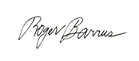 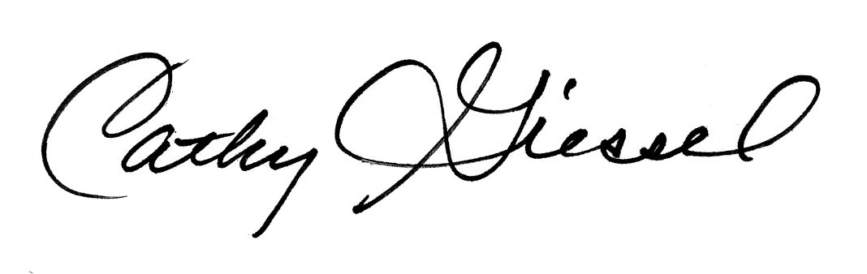

Representative Roger Barrus Speaker Thomas Lubnau Senator Cathy Giessel

Utah State Legislature Wyoming Legislature Alaska Legislature

Chairman, EPSC Immediate Past Chairman, EPSC Chairman-Elect, EPSC

CC:

Senator Lamar Alexander

Senator John Barrasso

Senator Maria Cantwell

Senator Christopher Coons

Senator Jeff Flake

Senator Al Franken

Senator Martin Heinrich

Senator Dean Heller

Senator John Hoeven

Senator Tim Johnson

Senator Mary Landrieu

Senator Mike Lee

Senator Joe Manchin

Senator Rob Portman

Senator James Risch

Senator Bernard Sanders

Senator Brian Schatz

Senator Tim Scott

Senator Debbie Stabenow

Senator Mark Udall

1. “Reductions in disposition of mineral lease revenue pursuant to sequester” email from Adam Vann. March 27, 2013.